# **Automatic Transmission Controller**

## Introduction:

The block diagram shows the power flow in a typical automotive drivetrain. Nonlinear ordinary differential equations model the engine, four-speed automatic transmission, and vehicle. The model directly implements the blocks from this figure as modular Simulink subsystems. On the other hand, the logic and decisions made in the Transmission Control Unit (TCU) do not lend themselves to well-formulated equations. TCU is better suited for a Stateflow representation. Stateflow monitors the events which correspond to important relationships within the system and takes the appropriate action as they occur.

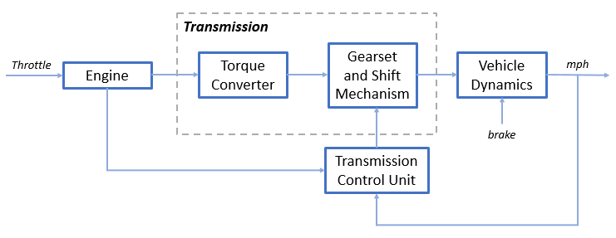

Fig1: Automatic Transmission Controller Block Diagram

The throttle opening shown in the block diagram is one of the inputs to the engine. The engine is connected to the impeller of the torque converter which couples it to the transmission (see Equation 1).

**Equation 1**

$$I_{ei} \dot{N}_e = T_e -T_i $$

$$ N_e = \mbox{ engine speed (RPM)}$$

$$I_{ei} = \mbox{ moment of inertia of the engine and the impeller}$$

$$T_e, T_i = \mbox{ engine and impeller torque}$$

The input-output characteristics of the torque converter can be expressed as functions of the engine speed and the turbine speed. In this model, the direction of power flow is always assumed to be from the impeller to the turbine (see Equation 2).

**Equation 2**

$$T_i = \frac{N_e^2}{K^2}$$

$$K= f_2 \frac{N_{in}}{N_e} = \mbox{ K-factor (capacity)}$$

$$N_{in} = \mbox{ speed of turbine (torque converter output) = transmission input speed (RPM)}$$

$$R_{TQ} = f_3 \frac{N_{in}}{N_e} = \mbox{ torque ratio}$$

The transmission model is implemented via static gear ratios, assuming small shift times (see Equation 3).

**Equation 3**

$$R_{TR} = f_4(gear) = \mbox{ transmission ratio}$$

$$T_{out} = R_{TR} T_{in}$$

$$N_{in} = R_{TR} N_{out}$$

$$T_{in}, T_{out} = \mbox{ transmission input and output torques}$$

$$N_{in}, N_{out} = \mbox{ transmission input and output speed (RPM)}$$

The final drive, inertia, and a dynamically varying load constitute the vehicle dynamics (see Equation 4).

**Equation 4**

$$ I_v \dot{N}_w = R_{fd}(T_{out}-T_{load})$$

$$I_v = \mbox{ vehicle inertia}$$

$$N_w = \mbox{ wheel speed (RPM)}$$

$$R_{fd} = \mbox{ final drive ratio}$$

$$T_{load} = f_5(N_w) = \mbox{ load torque}$$

The load torque includes both the road load and brake torque. The road load is the sum of frictional and aerodynamic losses (see Equation 5).

**Equation 5**

$$ T_{load} = sgn(mph) (R_{load0} + R_{load2} mph^2 + T_{brake}) $$

$$ R_{load0}, R_{load2} = \mbox{ friction and aerodynamic drag coefficients} $$

$$ T_{load}, T_{brake} = \mbox{ load and brake torques} $$

$$ mph = \mbox{ vehicle linear velocity}$$

## Transmission Shift Point Graph:

The model programs the shift points for the transmission according to the schedule shown in the figure below. For a given throttle in a given gear, there is a unique vehicle speed at which an upshift takes place. The simulation operates similarly for a downshift.

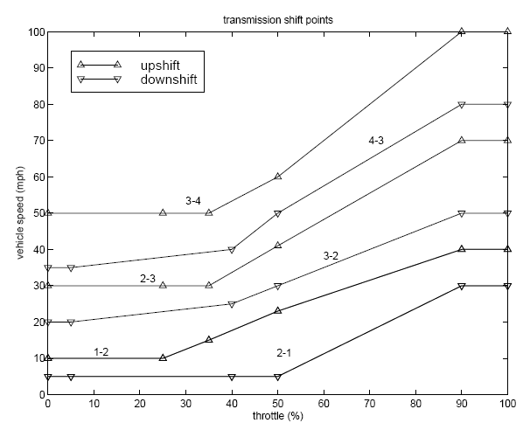

Fig 2: Transmission shift point VS Vehicle speed Graph

## Modelling:

The Engine subsystem consists of a two-dimensional table that interpolates engine torque versus throttle and engine speed. The figure below shows the composite Engine subsystem.

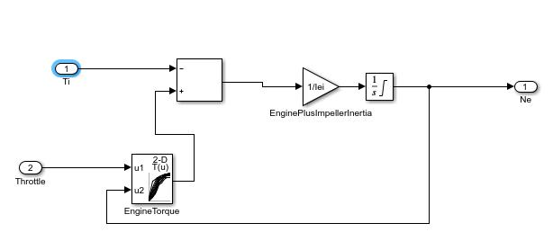

Fig 3: Engine Subsystem

The Torque Converter and the Transmission Ratio blocks make up the Transmission subsystem, as shown in the figure below. Double click on the Transmission subsystem in the model window to view its components.

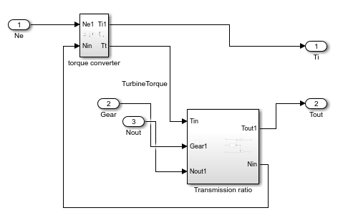

Fig 4: Transmission Subsystem

The Torque Converter is a masked subsystem, which implements Equation 2. The mask requires a vector of speed ratios ( Nin/Ne ) and vectors of K-factor (f2) and torque ratio (f3). This figure shows the implementation of the Torque Converter subsystem.

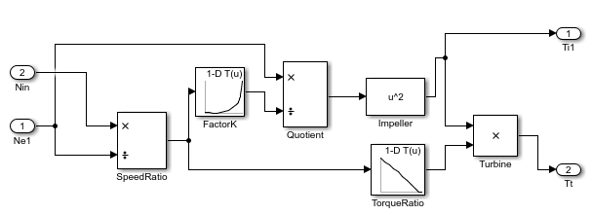

Fig 5: Torque convertor

The transmission ratio block determines the ratio shown in Table 1 and computes the transmission output torque and input speed, as indicated in Equation 3. The figure that follows shows the block diagram for the subsystem that realizes this ratio in torque and speed.

**Table 1:** Transmission gear ratios

gear Rtr = Nin/Ne

1 2.393

2 1.450

3 1.000

4 0.677

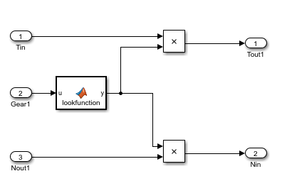

Fig 6: Transmission Ratio Subsystem

The Stateflow block implements gear selection for the transmission. The Model Explorer is utilized to define the inputs as throttle and vehicle speed and the output as the desired gear number. Two dashed AND states keep track of the gear state and the state of the gear selection process. The overall chart is executed as a discrete-time system, sampled every 40 milliseconds. The Stateflow diagram shown below illustrates the functionality of the block.

The shift logic behaviour can be observed during simulation by enabling animation in the Stateflow debugger. The selection\_state (always active) begins by performing the computations indicated in its during function. The model computes the upshift and downshift speed thresholds as a function of the instantaneous values of gear and throttle. While in steady\_state, the model compares these values to the present vehicle speed to determine if a shift is required. If so, it enters one of the confirm states (upshifting or downshifting), which records the time of entry.

If the vehicle speed no longer satisfies the shift condition, while in the confirm state, the model ignores the shift and it transitions back to steady\_state. This prevents extraneous shifts due to noise conditions. If the shift condition remains valid for a duration of TWAIT ticks, the model transitions through the lower junction and, depending on the current gear, it broadcasts one of the shift events. Subsequently, the model again activates steady\_state after a transition through one of the central junctions. The shift event, which is broadcast to the gear\_selection state, activates a transition to the appropriate new gear.

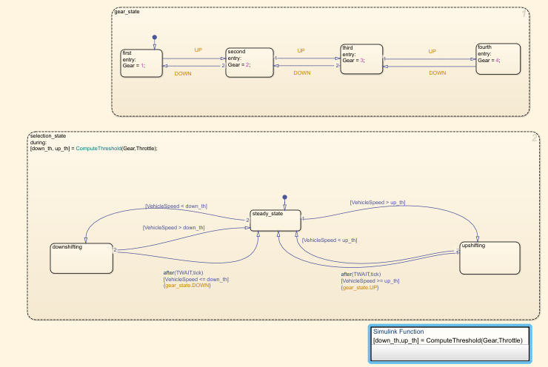

Fig 7: Stateflow Chart

The Vehicle subsystem uses the net torque to compute the acceleration and integrate it to compute the vehicle speed, per Equation 4 and Equation 5. The parameters entered in the menu are the final drive ratio, the polynomial coefficients for drag friction and aerodynamic drag, the wheel radius, vehicle inertia, and initial transmission output speed which are added in model workspace.

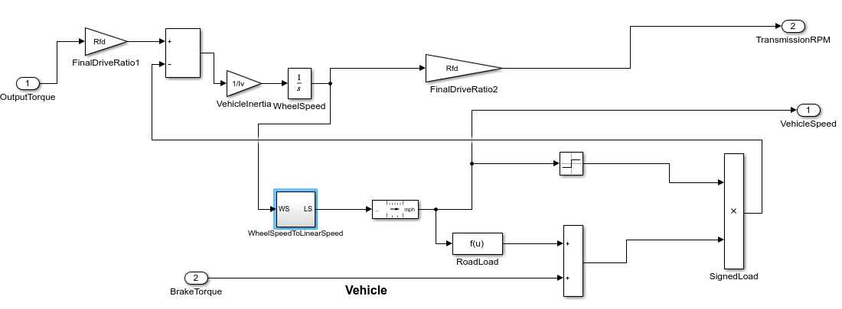

Fig 8: Vehicle subsystem

## Skills Demonstrator while modelling:

### Callback Function:

In the model closeFcn is used as callback function to clear the variable from the workspace associated with the model while closing it because if you close the model and open another one, there is a possibility that the newly opened model has the same variable and if not cleared the variable of previous model then those will be assigned to present model giving false results.

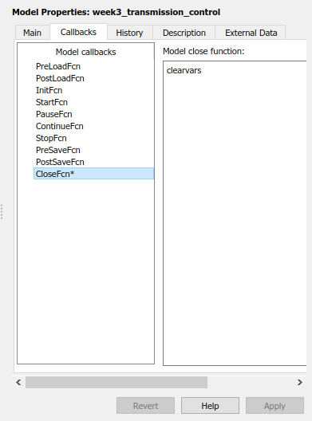

Fig 9: Callback Function

### Data Inspector:

In data inspector we can observe one or multiple signals of the model by logging them and compare or differentiate them at the same time by observing them on same graph or different graph.

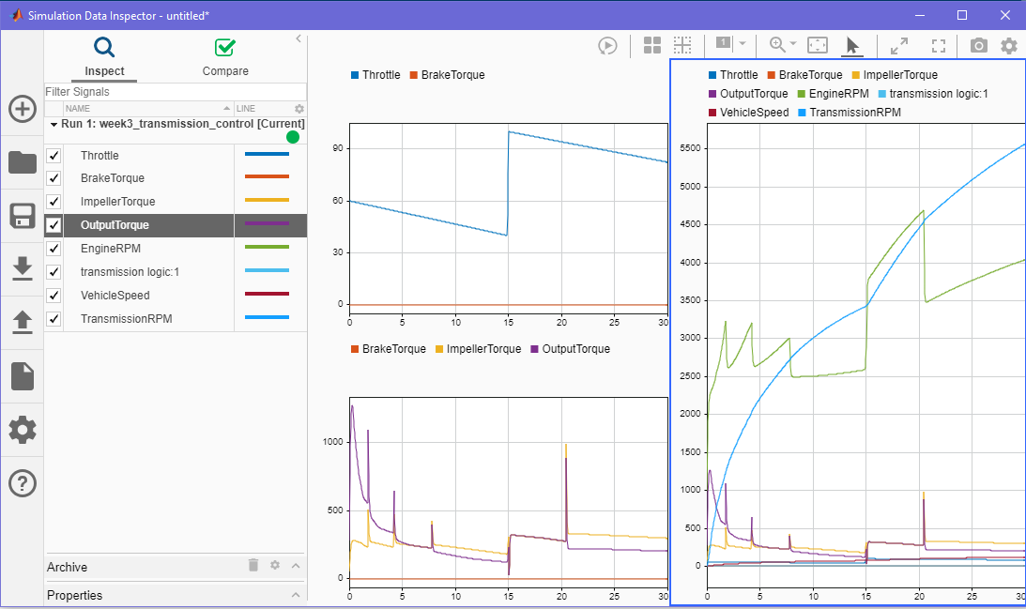

Fig 10: Data Inspector

### Solver Selection strategy:

The model uses the ode5 Dormand-Prince formula to compute the model state at the next time step as an explicit function of the current value of the state and the state derivatives approximated at intermediate points. It is used for the most accurate output.

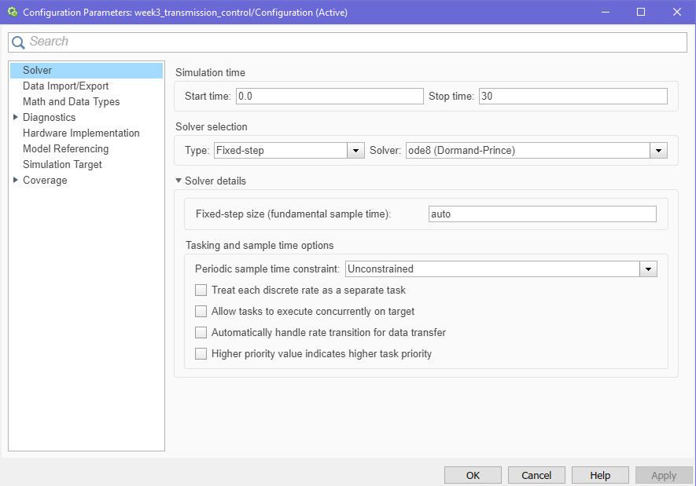

Fig 11: Solver Selection Strategy

### MATLAB Function block:

MATLAB Function block is used in the model to change the transmission gear ratios for 4 different gears.

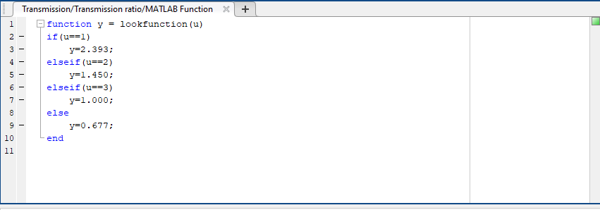

Fig 12: MATLAB Function Block

### Look-Up table:

The model uses 3 lookup tables.

1. One 2-D lookup table consists of the data for the Engine torque in the engine block.

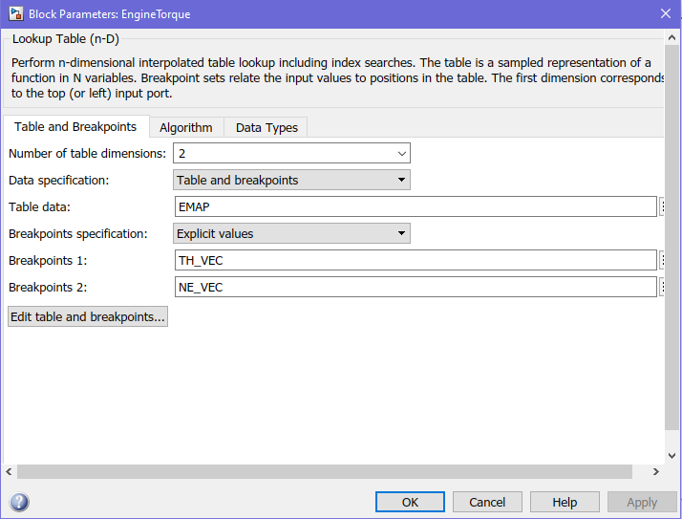

Fig 13: 2D lookup Table

1. There are two 1-D lookup tables that consists the data for Speed Ratio to Factor K and Speed Ratio to Torque Ratio. These three ratio speeds are present as an array in CONVERTER\_DATA variable.

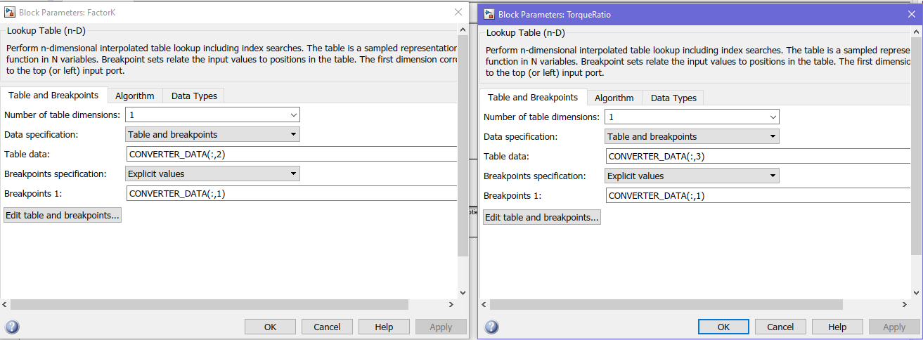

Fig14: 1D Lookup Table

### Signal Builder:

The model uses the signal builder to generate signals for throttle and brake inputs in 4 conditions:

* Passing Manoeuvre
* Gradual Acceleration
* Hard Braking
* Coasting

Passing Maneuver: Gradual Acceleration:

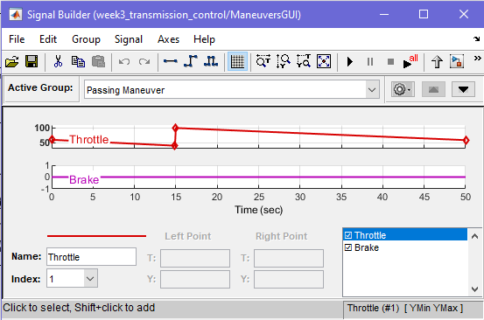 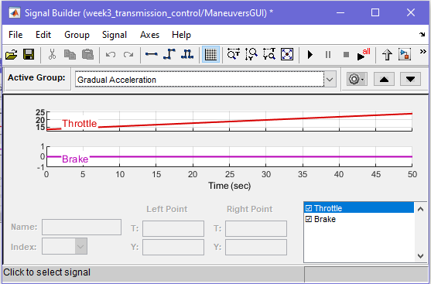

Hard Braking: Coasting:

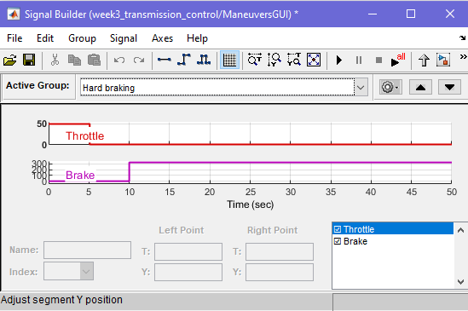 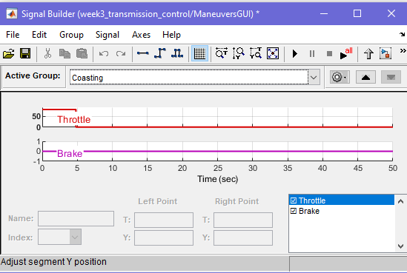

## RESULT:

Passing Maneuver: Gradual Acceleration:

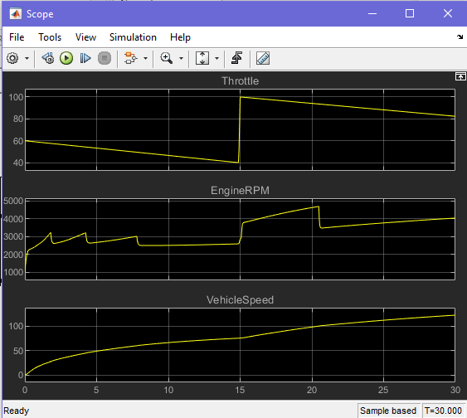 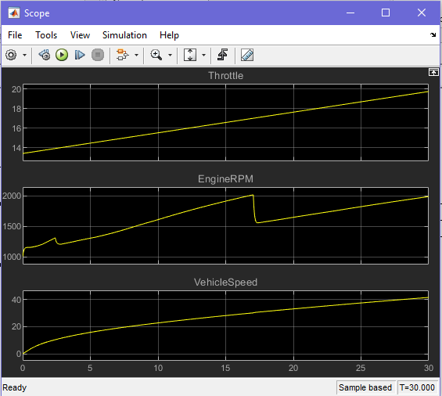

Hard Braking: Coasting:

